WEB TECHNOLOGY PROJECT REPORT

TRITINERARY

AMOGH GARG-2020UCO1688, ANANT-2020UCO1693, DAKSH CHETIWAL-2020UCO1646

**ABOUT WEBSITE**

Users can browse our curated selection of tourist attractions from the discover page to plan their next getaway.Any of the locations displayed on our website can be added to the User’s personal itinerary and they can remove it if they change their mind.

# FUNCTIONALITIES:

**1. HOME PAGE:** The first page which is visible to users on opening the site.

**2. DISCOVER PAGE**-Users can take a look at various tourist places which are sorted in a state-wise manner. The various places are provided with their description in order to make it easier for the users to plan their trip.

**3. MY ITINERARY**-In this section a user can make his/her personalized itinerary for a trip, add places to visit day-wise and delete from itinerary. Itinerary can only be made after signing-up/logging-in and will be saved for future references and editing.

**4. SIGN-UP AND LOGIN PAGES**-User can sign-up/login using these pages.

**SCREENSHOTS**

# HOME:

# SIGNUP/LOGIN:

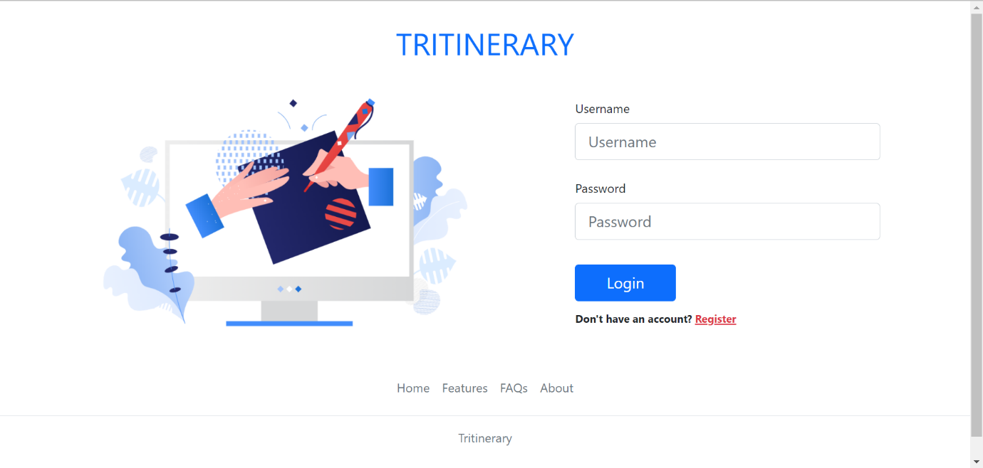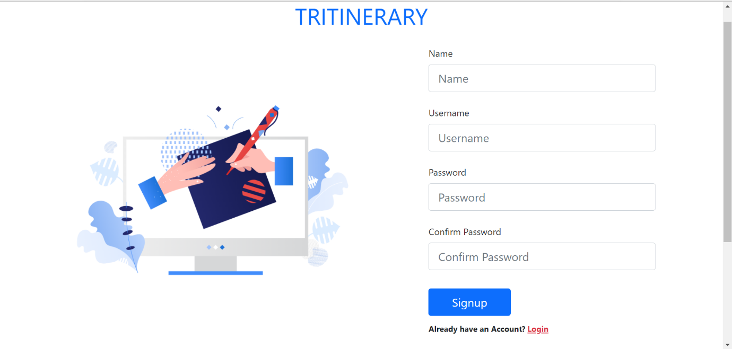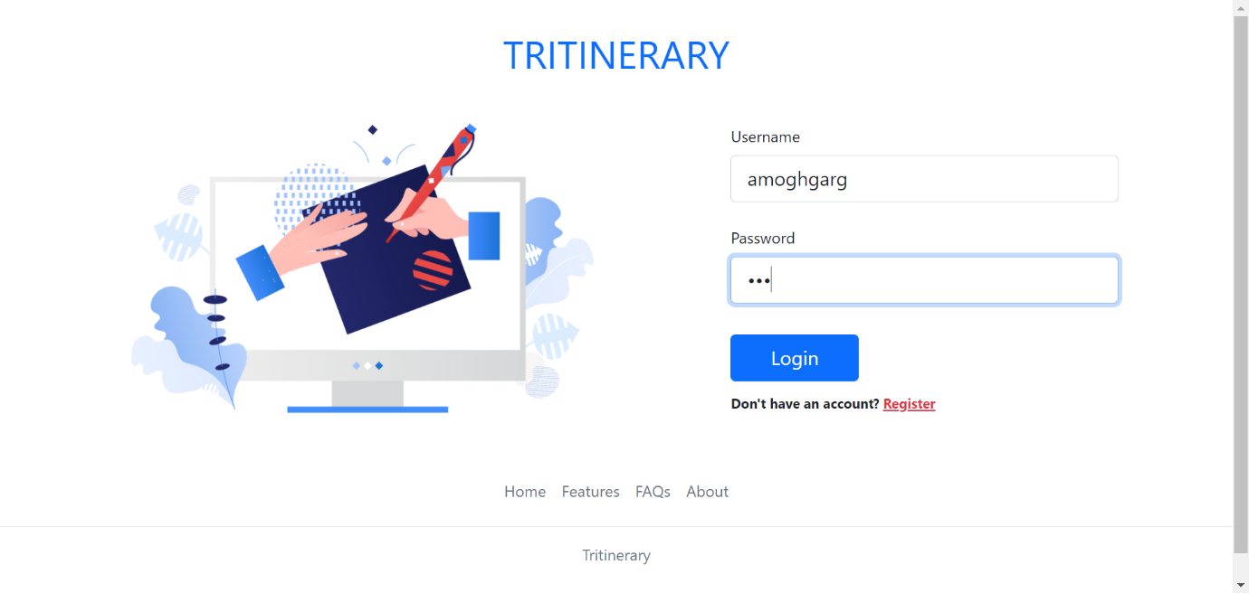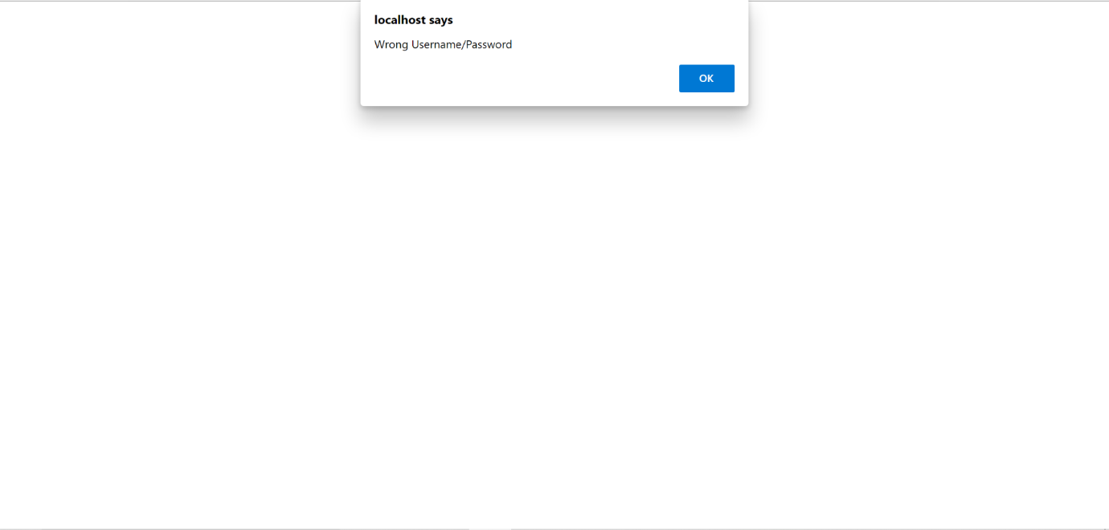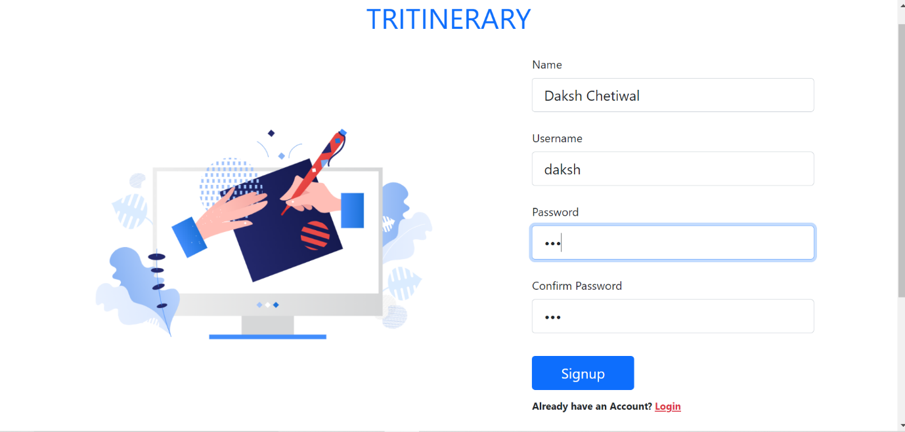

# TRITINERARY:

# 

# 

# DISCOVER PAGE:

**COMPETITORS**

Websites like TripAdvisor and Goibibo are our main competitors because they are also involved with rating and grading tourist attractions. While they are community driven, we give our users a curated selection. Websites such as trivago and hotels.com are not competitors because these focus on booking of hotels while our objective is location scouting. What makes us different from them is that in our website users can make their own personalized itinerary and change it accordingly. We provide various options of tourist attractions and option to make itinerary at the same platform which will make it easier for the users to plan their trips. This functionality is not provided by any of our competitors.

**TECHNOLOGIES USED**

1. HTML

2. CSS

3. JAVASCRIPT

4. BOOTSTRAP

5. PHP

6. MYSQL

**CONTRIBUTIONS**

Amogh Garg- Was responsible for the back-end part of the project and made functional sign-up/login pages. Also made the Itinerary functionality of the website in which users can make their personalized itinerary. All this work was done using php, mysql and html.  
Anant- Made the Home and Discover pages using html and applied Javascript to add events responses of these two pages in order to make the website more user friendly.  
Daksh Chetiwal- Was responsible for the making our website more appealing to the users and worked on CSS/BOOTSTRAP of all the pages. Also made the Navigation-Bar and the footer of the website.